COMP2113 Programming Technologies /
ENGG1340 Computer Programming II
Module 6 Checkpoint Exercise
Name: Zhang Yikun
University ID: 3036482333

Instructions:
For each single question or each group of questions in the Checkpoint exercise, please type your answer right after the question in this Word document.

Checkpoint 6.1 (Please submit your answer to Moodle)
There may be error(s) in the following statements. Correct the error(s) if any, if no error, please write “no error”.
a) double a [1] [2] = {{2,3}, {3,2}};
b) double b [1] [2] = {{3}};
c) char b[1000] = "string";
Ans:
- double a[][2] = {{2,3}, {3,2}};
- no error
- no error

Checkpoint 6.2 (Please submit your answer to Moodle)
Consider the following code:
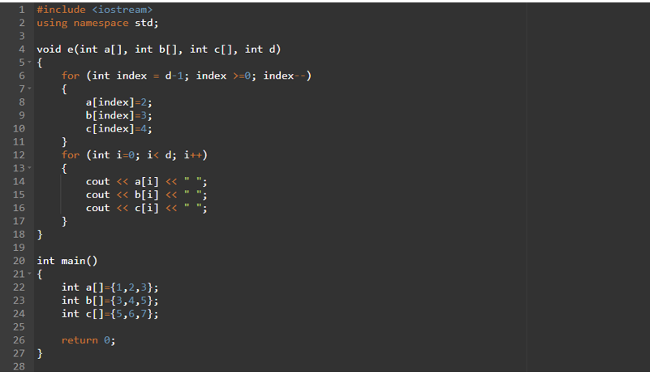
a) What is the output if the above program is executed? (if no output, please write “no output”)
b) What is the output if e(a,b,c,3); is added to line 25? (if no output, please write “no output”)
c) What is the output if e(a,b,c,5); is added to line 25? (if no output, please write “no output”)
Ans:
- no output
- 2 2 2 3 3 3 4 4 4
- no output

Checkpoint 6.3 (Please submit your answer to Moodle)
Assume a 3D double array x is defined as
double x[2][2][3] = { { {3, 4, 2}, {0, -3, 9} }, { {13, 4, 56}, {5, 9, 3}}}; Write a program that would find the maximum and minimum values in this 2-by-2-by-3 double array x. Print the maximum and minimum value after they are found.
#include <iostream>
using namespace std;
int main(){
double a[2][2][3]={{{3,4,2},{0,-3,9}},{{13,4,56},{5,9,3}}};
double max_val=a[0][0][0];
double min_val=a[0][0][0];
for (int i=0;i<2;i++)
for (int j=0;j<2;j++)
for (int k=0;k<3;k++) {
if (a[i][j][k]>max_val) max_val=a[i][j][k];
if (a[i][j][k]<min_val) min_val=a[i][j][k];
}
cout<<"Maximum value: "<<max_val<<endl;
cout<<"Minimum value: "<<min_val;
return 0;
}

